MCQ ANSWER
- 4
- 1,3,4,5
- 1
- 4
- 3
- 2
- 2,4,5
- 4
- 2
- 4
- 4
- 1,3,4
- 1
- 2
- 4
- 3
- 1
- 2
- 3
- 2

Section B - Admin Configuration
Workflow Rule-

If Amount > $10,000 send an email alert on opportunity closed won (Stage field value) to pgoyal@kloudrac.com and msharma@kloudrac.com

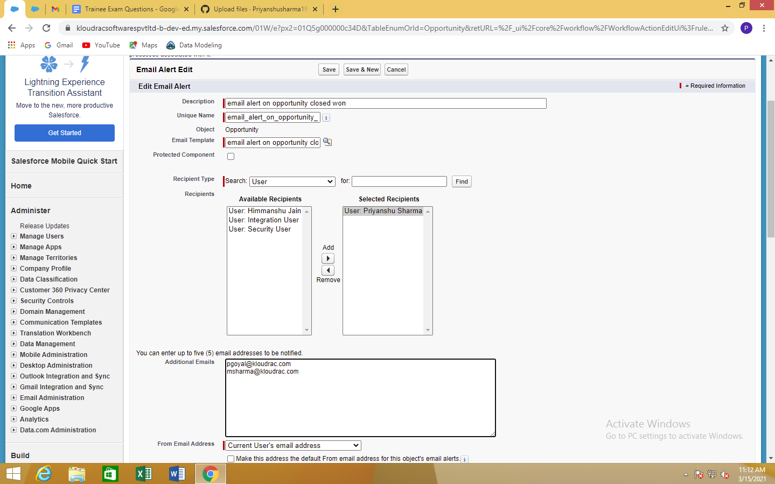
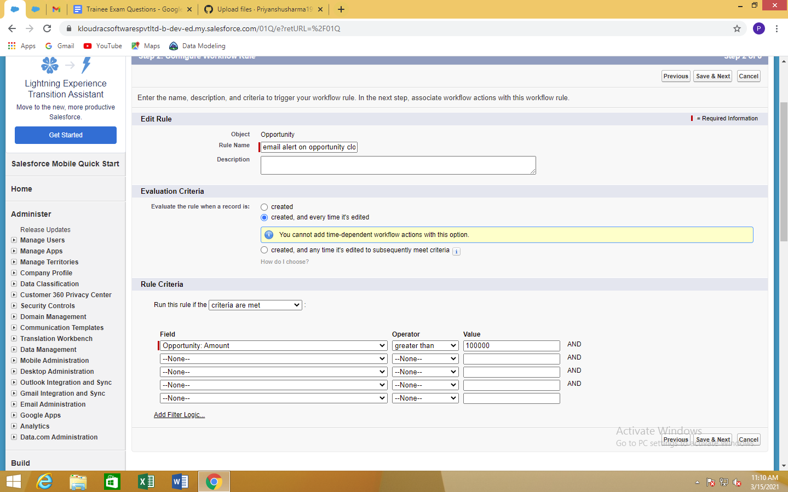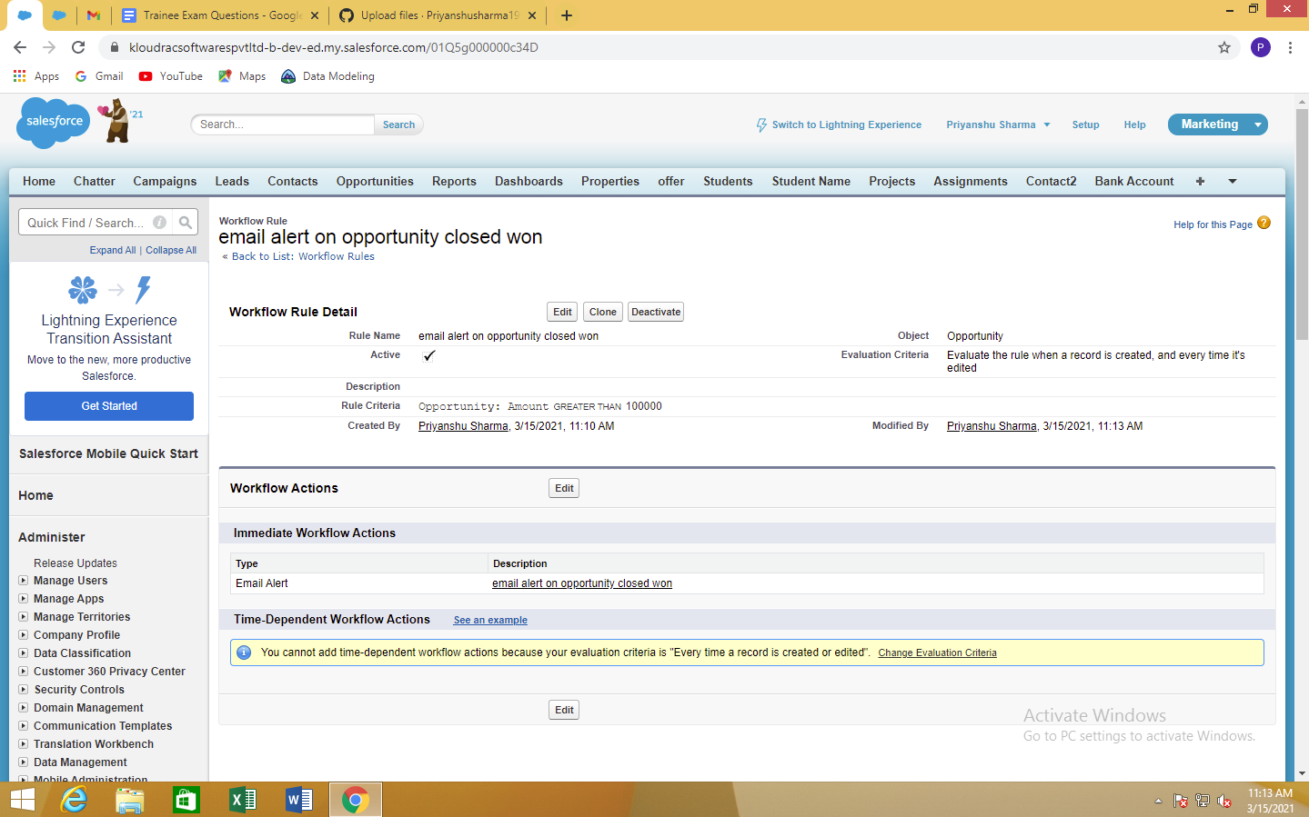
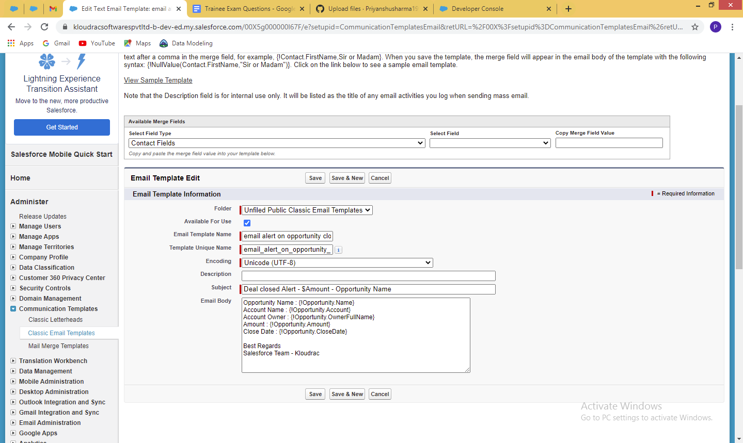

Validation Rules -

- Only Admins should be allowed to change the account owner. Error Message : "You are not authorised to transfer the account
.

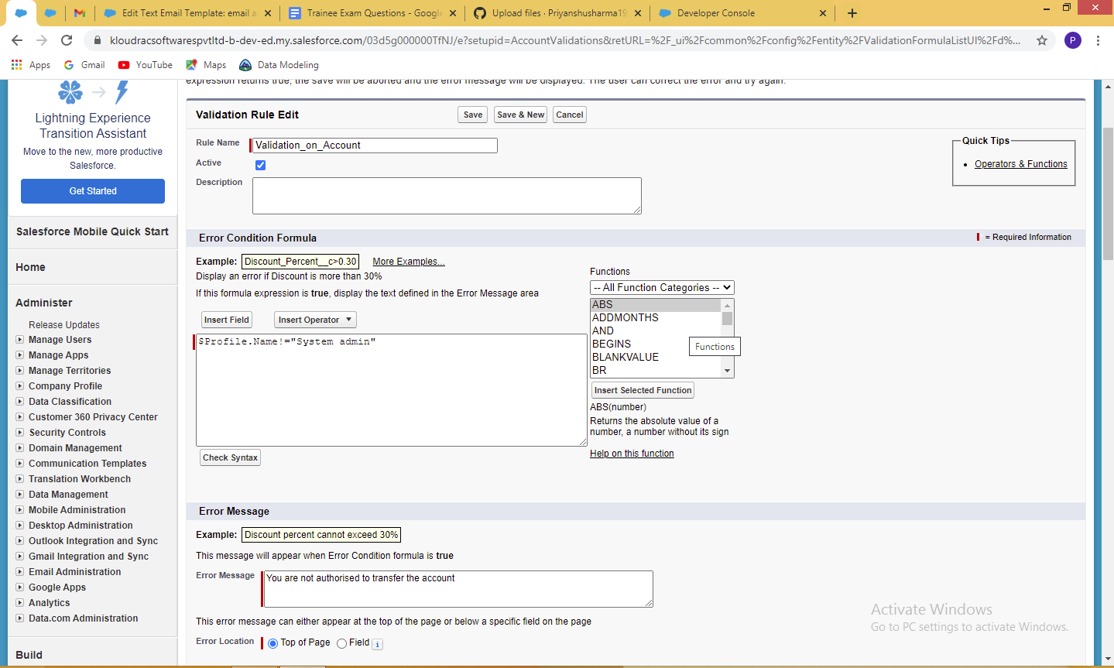

Process Builder-

Kloudrac Softwares would like to set up a process where an event will get created on opportunity creation and an automated approval will go to the opportunity owner's manager whenever discount > 20% on opportunity.

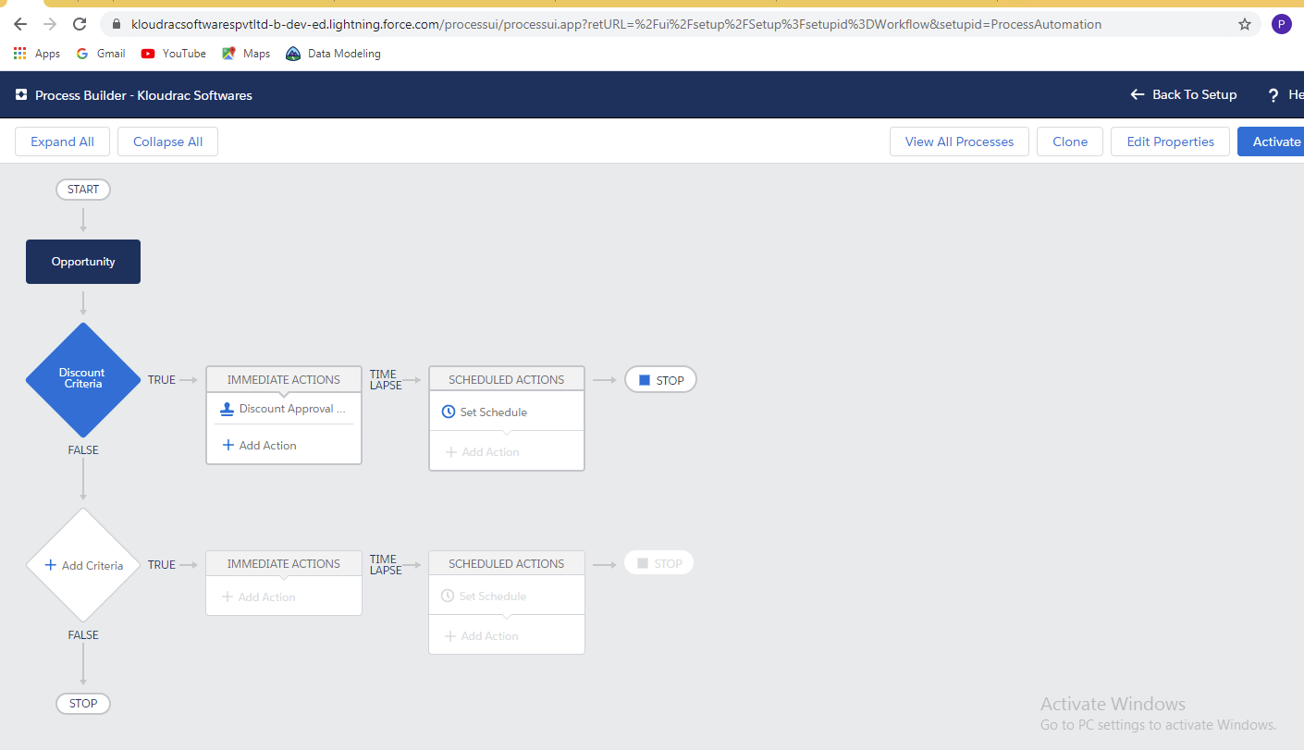

Triggers-
2. While creating a new Opportunity then starting 5 Products should get automatically added under this Opportunity.

trigger OpportunityProducts on Opportunity (before insert) {
List<Opportunity> opp = new List<Opportunity>();
Set<id> setid= new Set<id>();
for(Opportunity lst: Trigger.New)
{
if(lst.AccountId!=null)
{
setid.add(lst.AccountId);
}
}
Product prod = [SELECT Id FROM Product WHERE Id IN:setid];
List<OpportunityLineItem> lines = new List<OpportunityLineItem>();

}

}

